
CONFIDENTIAL CS/NOV 2026/ICT450

UNIVERSITI TEKNOLOGI MARA FINAL EXAMINATION

COURSE
COURSE CODE
EXAMINATION TIME
DATABASE DESIGN AND DEVELOPMENT

ICT450
NOVEMBER 2026
3 HOURS

INSTRUCTIONS TO CANDIDATES

- This question paper consists of five (5) questions.

- Answer ALL questions in the Answer Booklet. Start each answer on a new page.

- Do not bring any material into the examination room unless permission is given by the invigilator .
- Please check to make sure that this examination pack consists of: i) the Question Paper
  - an Answer Booklet - provided by the Faculty

- Answer ALL questions in English.

DO NOT TURN THIS PAGE UNTIL YOU ARE TOLD TO DO SO

This examination paper consists of 6 printed pages.

QUESTION 1 (20 marks)
a) Explain TWO (2) limitations of the file-based approach in business environment.
(4 marks)
b) Data models are used as a communication tool between database designers, programmers and users. Identify and briefly explain any TWO (2) basic building blocks used in data models.
(4 marks)
c) Table 1 shows the sample data for an art and culture club in Jasin city.
i) Explain THREE (3) characteristics of a relational table that have been violated in Table 1.
(6 marks)
ii) As a database designer, briefly explain possible courses of action to handle each problem stated in (i).
(6 marks)
Table 1
StudID | Name | Name | Skill
2023123456 | Izyan Mimiey | Ahmad | Modern Dance, Singing
2023456789 | Jeonghan | Lee | Traditional Dance
2023455abc | Hafizal | Azri | Modern Dance, Playing Drum
QUESTION 2 (20 marks)
a) The evolution of data models has been driven by the increasing complexity of data storage, management, and analysis needs over time. Match the suitable data models with their correct statements.
(4 marks)
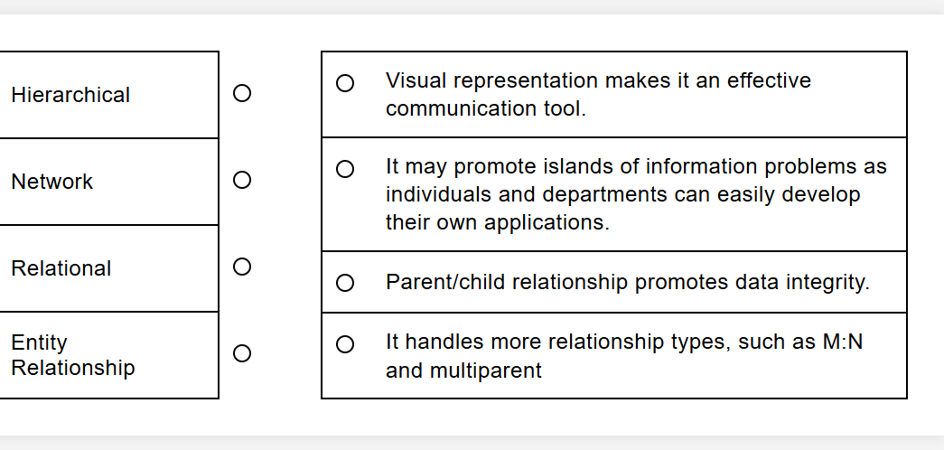
b) The following relational schema provides a basic structure for managing pet sales in a pet shop system. It includes customer information, pet information and purchase transactions.
PETS (PetID, Name, Species, Age, Price, PurchaseID*)
CUSTOMERS (CustomerID, Name, Address, Phone, Email)
PURCHASES (PurchaseID, CustomerID*, PurchaseDate)
Based on the relational schema above, describe TWO (2) related business rules.
(4 marks)
c) Security is a crucial aspect of DBMS. Describe THREE (3) reasons for protecting data from unauthorized users.
(6 marks)
d) Briefly explain THREE (3) challenges in handling multimedia data compared to traditional structured data.
(6 marks)
QUESTION 3 (20 marks)
Figure 2 shows a report of an employee evaluation result in IT Creative Solutions Sdn. Bhd. in Shah Alam. The report contains all information related to one of the employees in this company. Each employee has been assigned to several projects. Meanwhile, each project has been assigned to several employees. Each project has been supervised by one employee (Supervisor). Supervisor also manages several employees.
Based on the information given, answer the following questions:
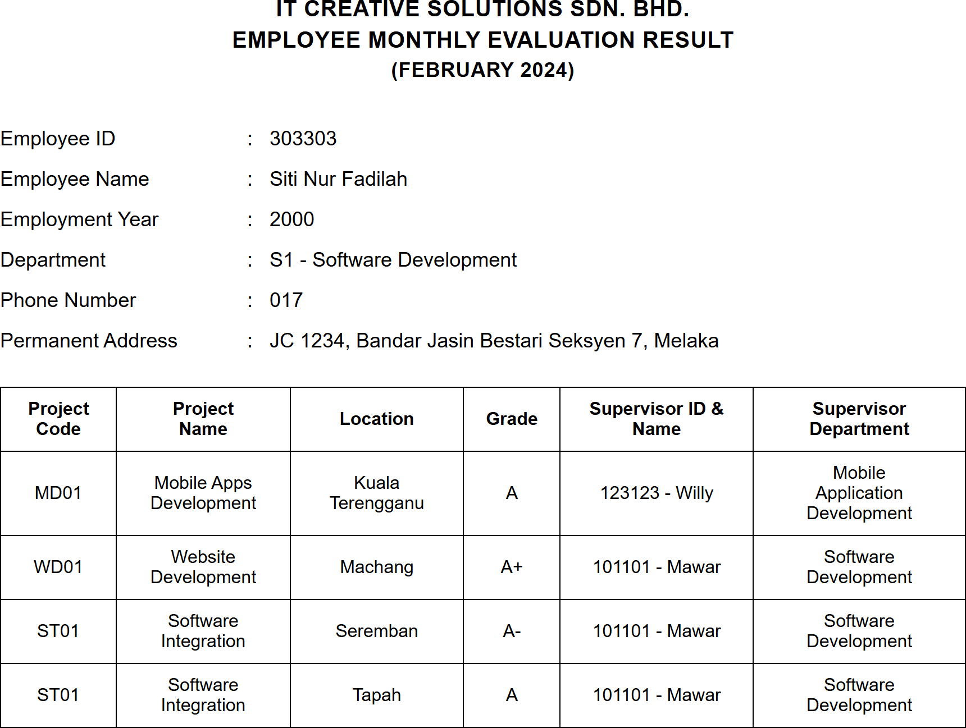
Figure 2 : Employee evaluation report
a) State the normal form of the Figure 2 above. Explain your answer with reasons.
(3 marks)
b) Convert the report into a relational schema. Identify the primary key(s) and partial dependencies and/or transitive dependencies.
(6 marks)
c) Normalize the relational schema in (b) until third normal form (3NF). Show all the steps involved.
(11 marks)
QUESTION 4 (20 marks)
The relational schema below shows the e-Travel Package database system for one of the local travel agents in Malaysia.
CUSTOMERS (CustomerID, FirstName, LastName, PhoneNumber)
BOOKING (BookingID, BookingDate, NumberOfPax, TripDate, CustomerID*, GuideID*, PackageID*)
GUIDE (GuideID, GuideName, BasicSalary, HireDate)
PACKAGE (PackageID, PackageName, PricePerPax, PackageDetails)
Write the SQL statements based on the following requirements:
a) Calculate the total number of trips for each date.
(4 marks)
b) Display the details of customer who make a highest number of booking.
(4 marks)
c) Increase 10% of the salary for all guides who works on a trip in February 2025.
(4 marks)
d) Display the full name of packages that has been booked more than 70 times.
(4 marks)
e) Identify the total number of customers that make a booking in Feb 2025 until March 2025.
(4 marks)
QUESTION 5 (20 marks)
FreshBasket is a new company located in Jasin, Malacca, and operates an online grocery platform. As a database designer, you are tasked with designing a database system based on the following requirements:
- Customers register with their name, email, and address.
- Customers can place multiple orders, and each order belongs to one customer.
- Each order consists of multiple products, and a product can appear in many orders.
- Products have a ProductID, Name, Price, and belong to a Category.
- An invoice is issued for each order, containing the InvoiceNo, Date, and TotalAmount.
- Each order has exactly one invoice.
- Delivery is scheduled through a DeliverySlot (SlotID, Date, Time, Status), and each order must have one delivery slot.
Based on the given information:
a) Construct a complete Entity Relationship Diagram (ERD) with all of the required tables, attributes, and relationships using the Crow's Foot notation that reflects all of the given business rules.
(16 marks)
b) Identify TWO (2) relevant information that you can get from the ERD you constructed in (a).
(4 marks)
The OCR result should be empty, as the image contains only a stylistic horizontal line which must be ignored according to Rule 2. No text or placeholder characters should be output.
(4 marks)

